**Ibrahim Alzamil – 219211284**

**Fahad Alfawaz - 219110264**

**Library Management System**

**Website Description**

The Library Management System is a web-based application designed to help users browse and borrow books, while administrators can manage inventory, users, and transactions. It ensures a seamless and efficient book-lending process.

Key Features:

**Home Page**

• Provides an overview of the library system.

• Displays featured books, and announcements.

• Includes a search bar to quickly find books.

• Offers login options for users and admin.

**Catalog Page**

• Displays a list of available books with filtering options (by author, genre, availability).

• Users can view book details, including the title, author, category, and availability status.

• Allows users to borrow or reserve books if logged in.

• Supports a pagination system for large collections.

**Profile Page**

• Displays user details (name, email, membership ID).

• Shows a list of borrowed books with due dates.

• Allows users to renew or return books.

• Displays reservation status for books.

**Admin Page**

• A secured dashboard for managing the system.

• Features:

• Manage Books: Add, update, and remove books.

• Manage Users: Approve, remove, or edit user details.

• Track Transactions: View book checkouts, returns, and overdue books.

• Generate Reports: View statistics on book borrowing trends and overdue returns.

**Wireframe**

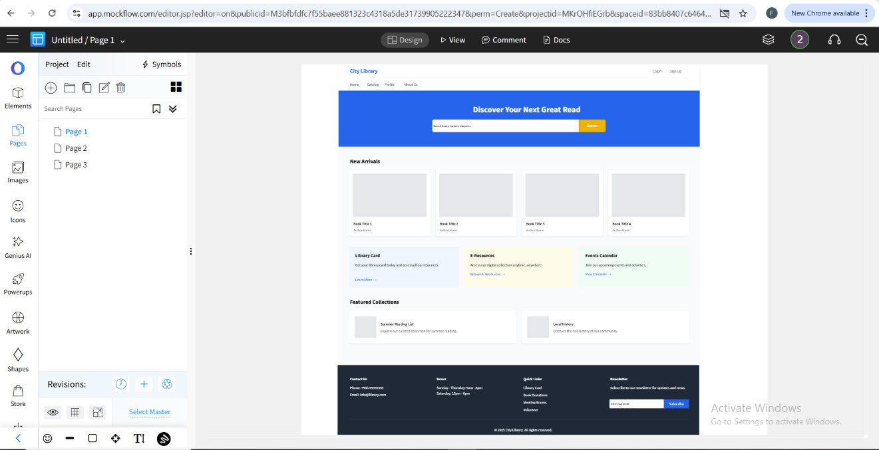

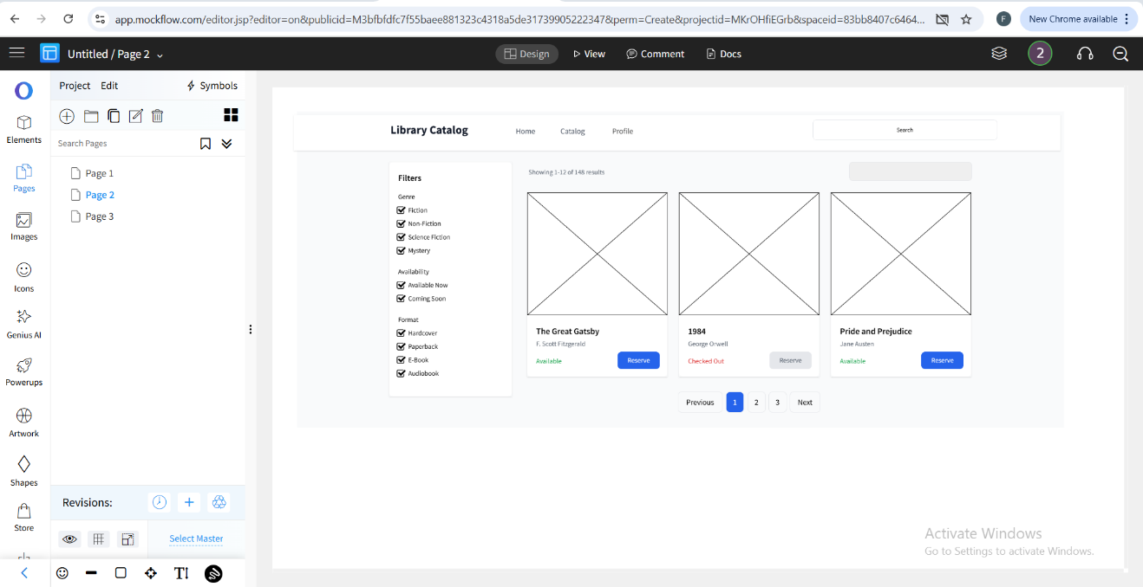

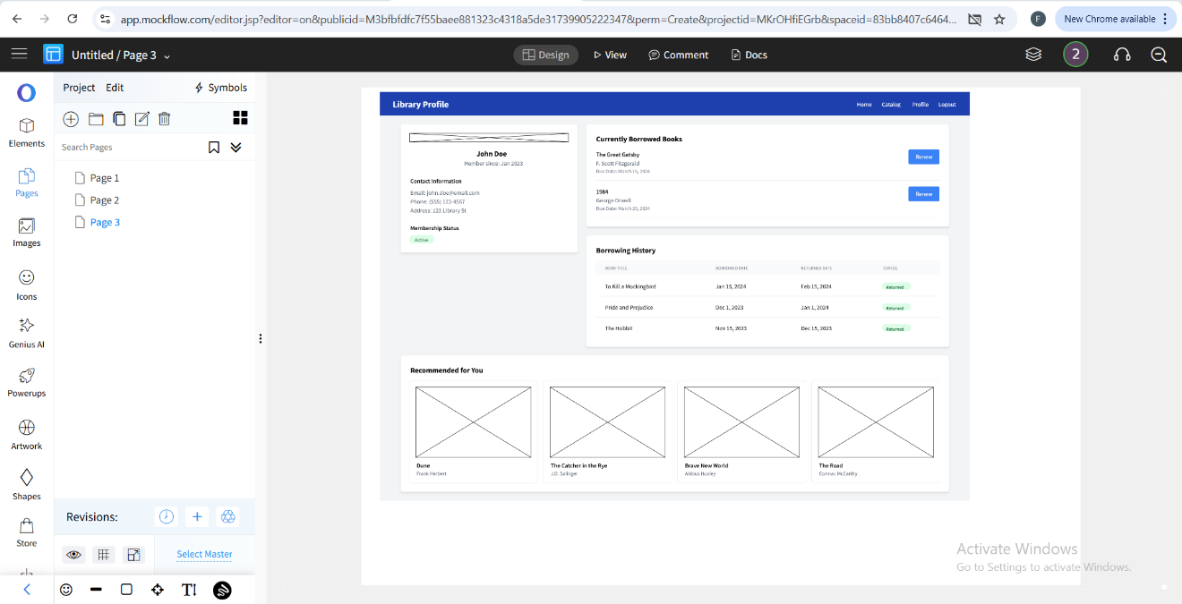

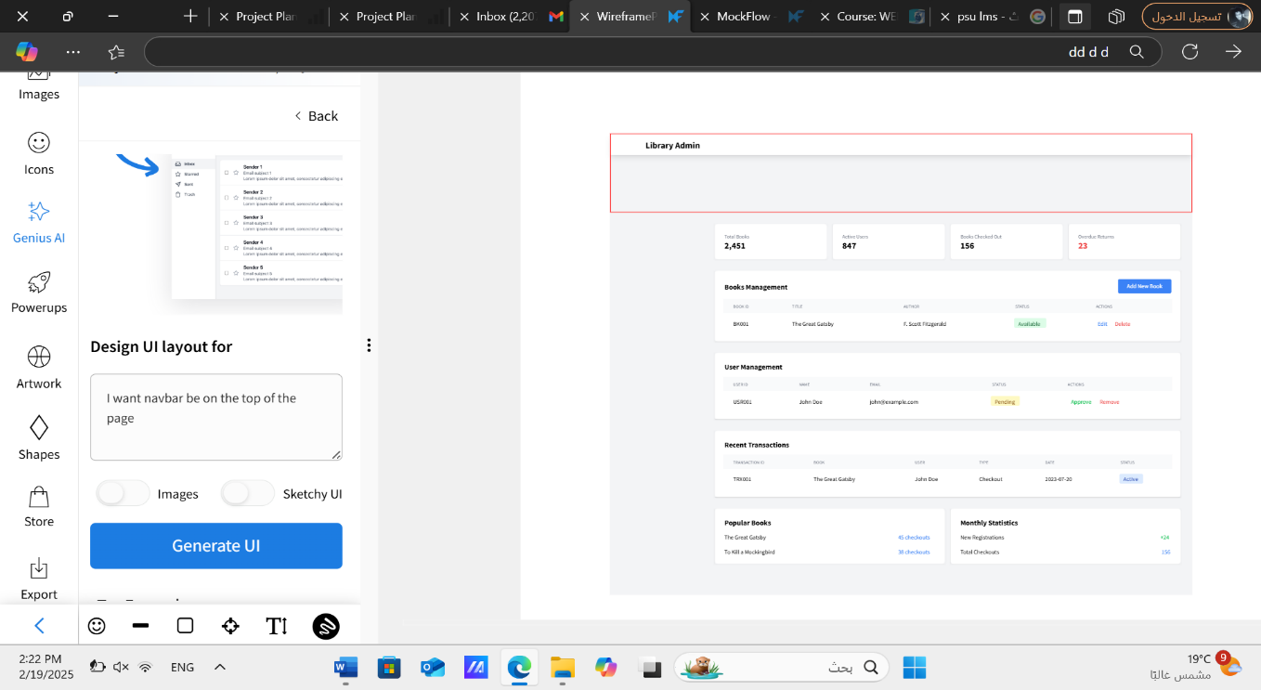

**SITEMAP**

